“アジアの祭典チャリティーバザー2014”が今年も開催されます！今年もアジア大洋州の26カ国が参加します。昨年の寄付金にて、サモア女性職業促進育成プロジェクトに3000リットルの水タンクを6つ、オリーブオイルとフェタウオイルを製作する搾取機などを含む機械、部品をそれぞれ3セットずつ寄贈させて頂きました。皆様のご協力本当にありがとうございました。深く御礼申し上げます。

今年もサモア独立国大使館からは大好評のサモア産ノニジュースやココナツソープ、ココナツオイル、テーブルクロス、クッションなど販売致します。また、抽選会では、航空券、着物、陶芸品など豪華賞品が当たります！皆様お誘い合わせの上、是非ご参加をお待ちしております。

日時：2014年4月8日 （火） 11：00－15：00
場所：ＡＮＡ インターコンチネンタル東京 地下1階大宴会場

チケットはサモア独立国大使館で販売しております！！
入場券：2,000円 （寄付）
（当日はご購入できない可能性がございます。前売り券のご購入をお勧め致します。）
ラッフル（福引券）：500円 （寄付）
（何枚でも購入可能です。当日お越しになれない場合に福引券をご購入頂いた場合は、半券をこちらで保管させて頂き、当選した場合は商品をALFS からお送り致します。）

チケット数に限りがございますのでお早目にご連絡頂ければ幸いです。チケットと当日のバザーの売上金はすべてバザーに参加のすべての国々に均等に分配され、アジア･太平洋諸国の女性や子供の支援、福祉、教育、医療、災害支援等の機関に寄付をさせて頂きます。

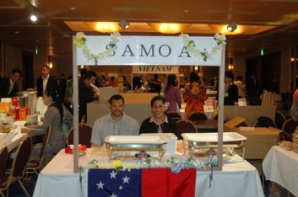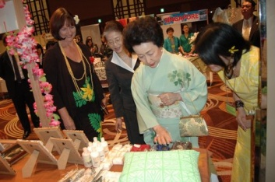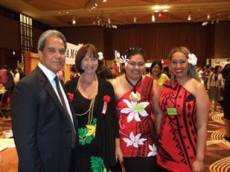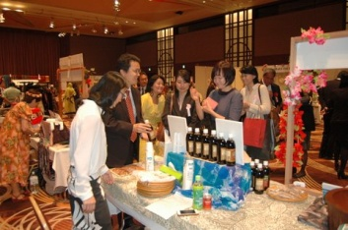
チケットのお問い合わせ、ご質問等は
サモア独立国大使館 松本 までお気軽にお問い合わせ下さい。
電話番号：03-6228-3692 ファックス：03-6228-3693
samoa_tokyo@samoaembassy.jp

Dear Friends,
Last year Samoa Embassy participated in the Asia Pacific Ladies Friendship Society’s fundraising events which involved an annual Bazaar and golf tournament. Proceeds of the fundraising were shared among Asia-Pacific Embassies to donate to charitable work, in respective countries, that encourages and supports the well-being and welfare of women and children in particular.
Samoa Embassy received her share and used it to buy 6 water tanks (3,000 litres per water tank) for the Samoan fine mat weavers in Savaii and machinery parts for the production of the virgin coconut oil and fetau oil. This assistance was channeled through the Women in Business Development Group in Samoa who also monitored these projects.
We are pleased to say that this is the third donation from the ALFS (since the Embassy became a member in 2010) which has assisted the community projects in Samoa. The first donation helped fund the public awareness campaign in the early set-up phase of the Samoa Cancer Society. The second donation was used to buy 25 hand sewing machines to assist the Satalo village’s sewing project monitored by the Ministry of Women, Community and Social Development.
We hope to keep working closely with ALFS to raise funds and awareness for community/grassroots-level projects that could make a direct impact and difference in the lives of families and people in the villages, mainly the women and children.
It is for this reason that I humbly request your kind support in this year’s Bazaar. We are selling raffle tickets and door tickets for the event. Embassies have to sell at least 200 raffle tickets (500yen for a ticket), and 100 door tickets (JPY2, 000 per ticket). This is how the bazaar raised the bulk of the money aside from the sales of country products in the Embassies’ booths during the event.
The raffle has a range of wonderful prizes to be won such as round trips to Asia-Pacific destinations, also, artifacts and cultural items from the region as shown in the attachment.
We would greatly appreciate any purchase you can make, and help in sharing this information with the Samoan community, friends and contacts.
For more information or buying a ticket, please do not hesitate to contact Mr. Rapture Pagaialii or Ms. Iyo Matsumoto by email or phone, any time.
Email: samoa_tokyo@samoaembassy.jp Telephone: 03-6228-3692.

